Supply Chain Management (SCM) — NPTEL
Week 11 · Session 3: GFA Hands-On — Excel Solver Formulas & Any Logistics (Multi-SKU)
1. Recap — Sessions 1 & 2
- Session 1: Digital twin — definition, 5 types (product → network of networks), 4 enabling technologies, 3 components
- Session 2: GFA case — optimization model formulated, distance formula explained, Excel + Any Logistics results shown
- This session: hands-on walkthrough — Excel formula breakdown + Any Logistics step-by-step with multi-SKU data

★ Same result from both tools: Optimal DC = lat 19.09, long 72.87 = Mumbai. This session shows HOW to reproduce it yourself.

2. Case Reminder — Pharma Company DC Location
- 4 markets: Pune (M1), Mumbai (M2), Ahmedabad (M3), Surat (M4)
- Known: annual demand + latitude/longitude per market
- Unknown: xDC (latitude of new DC), yDC (longitude of new DC)
- Objective: Minimize Z = Σ (Demand_i × Distance_i × $1/km/unit) over all 4 markets
- Initial DC assumption: lat = 20, long = 72 → Z = 12,44,89,119 (not optimal)
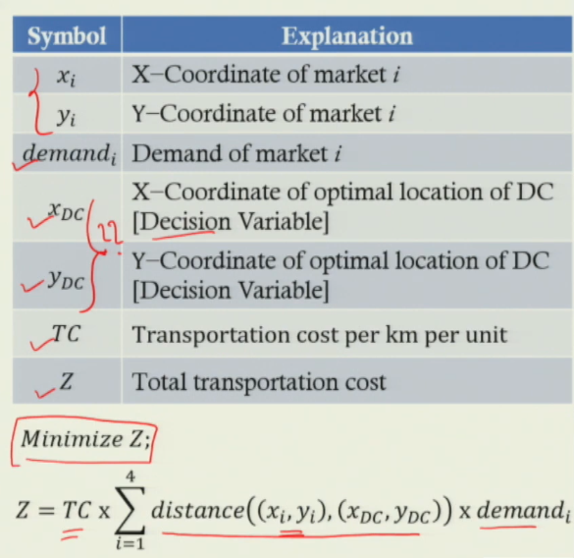
3. Excel — Formula Build-Up (Spherical Distance)
- The distance formula requires 5 intermediate calculations before arriving at km distance:
- Key naming convention: B7 = xDC (lat of DC), B8 = yDC (long of DC), D2 = xi (lat of market i), E2 = yi (long of market i)

Cell / Variable | Excel Formula | Explanation
d_long | = RADIANS(V8 − E2) | V8 = longitude of DC (yDC) | E2 = longitude of market i (yi) | RADIANS converts degrees to standard angular unit
d_lat | = RADIANS(B7 − D2) | B7 = latitude of DC (xDC) | D2 = latitude of market i (xi) | RADIANS applied for the same reason
A | = SIN(G2/2)^2 + COS(RADIANS(D2)) * COS(RADIANS(B7)) * SIN(H2/2)^2 | G2 = d_lat | H2 = d_long | D2 = lat of market | B7 = lat of DC. This is the Haversine intermediate term.
C | = 2 * ATAN2(SQRT(1−A), SQRT(A)) | ATAN2 is the two-argument arctangent function. Gives central angle C in radians.
Distance | = 6371 * C | 6371 = Earth's radius in km (constant). Distance in km = R × C.
Total Cost | = SUMPRODUCT(K2:K5, C2:C5, F2:F5) | K2:K5 = distances | C2:C5 = demands | F2:F5 = cost/km/unit. One formula gives total cost across all 4 markets.

Step-by-Step Formula Chain (for Market 1 = Pune)

Step 1 — d_long = RADIANS(V8 − E2)
Step 2 — d_lat = RADIANS(B7 − D2)
Step 3 — A = SIN(d_lat/2)^2 + COS(RADIANS(D2)) * COS(RADIANS(B7)) * SIN(d_long/2)^2
Step 4 — C = 2 * ATAN2(SQRT(1−A), SQRT(A))
Step 5 — Distance = 6371 * C [km, accounts for earth curvature]
Step 6 — Total Cost = SUMPRODUCT(distances_range, demands_range, cost_range)

- Important: apply the same formula for all 4 markets (rows 2–5) by changing D2→D3, E2→E3, etc. for each market
- B7 and B8 remain fixed references throughout — they are the decision variables
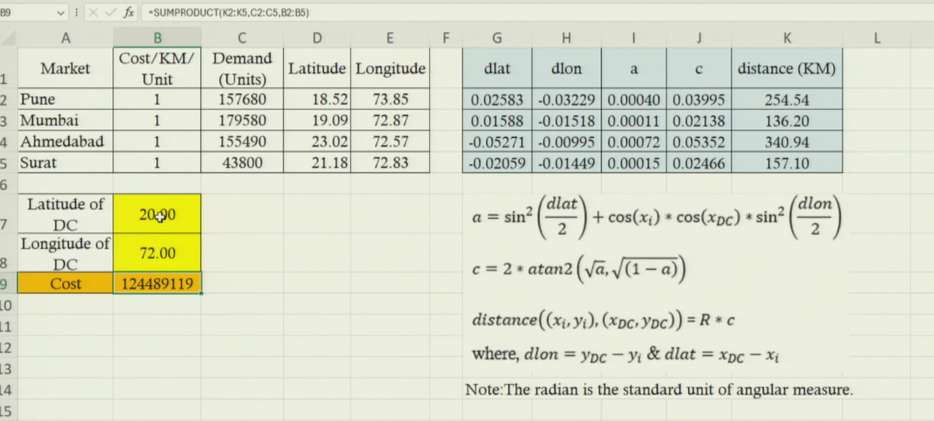
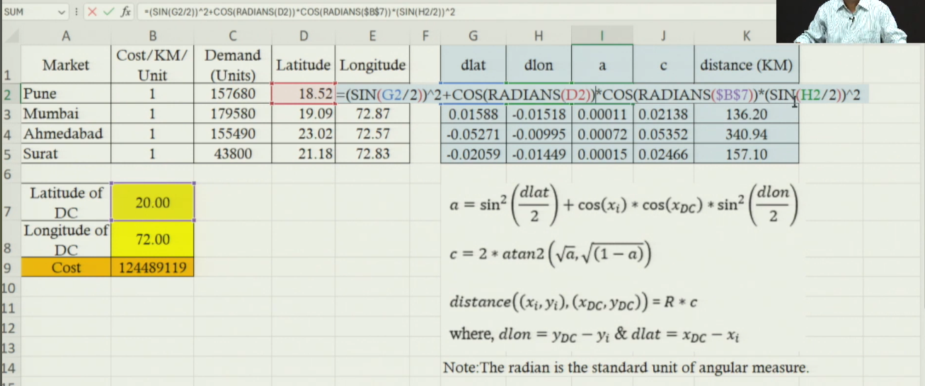
4. Excel Solver — Settings & Output
Solver Field | Value / Setting
Set Objective | Cell B9 (Total Cost)
To | Min (Minimize)
By Changing Variable Cells | B7:B8 (Latitude of DC, Longitude of DC)
Subject to Constraints | None — DC can be placed anywhere
Solving Method | GRG Non-linear — because spherical distance formula is non-linear
Optimal Output | B7 = 19.09 (lat), B8 = 72.87 (long) → Mumbai location
Minimized Cost | ₹9,73,92,135 (vs ₹12,44,89,119 at initial 20, 72)

- Confirm installation: Data tab → if Solver not visible: File → Options → Add-ins → Manage Excel Add-ins → check Solver Add-in → OK
- After solving: Mumbai distance = 0 (DC placed exactly at Mumbai coordinates) — confirms solution

★ Non-linear solver (GRG) required because ATAN2 and SIN/COS in the distance formula make the objective non-linear. Simplex LP will not work here.

5. Advanced Scenario — Multiple SKUs & Daily Demand
Why Complexity Increases
- Previous case: 1 product × 4 markets = 4 demand entries
- Advanced case: 4 SKUs × 4 markets = 16 demand entries (daily demand, not annual)
- Real companies have 20–100 SKUs across thousands of markets — Excel cannot handle this
- Excel limitation: cannot solve LP/NLP models with more than ~200 decision variables efficiently
- Solution: use Any Logistics software — handles this at scale in seconds
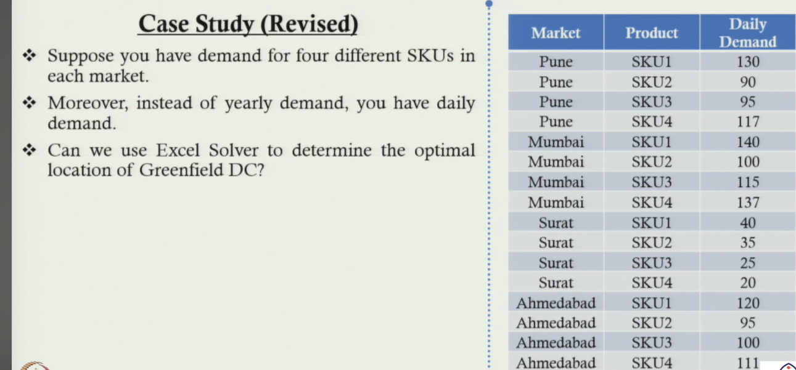
Multi-SKU Demand Data (Advanced Case)
Market | SKU1 (units/day) | SKU2 (units/day) | SKU3 (units/day) | SKU4 (units/day) | Coordinates (lat, long)
Pune | 130 | 90 | 95 | — | 18.52, 73.85
Mumbai | — | — | — | — | 19.09, 72.87
Ahmedabad | — | — | — | — | 23.02, 72.57
Surat | — | — | — | — | 21.18, 72.83
Note: full SKU demand per market entered in Any Logistics |  |  |  |  | 4 products × 4 markets = 16 demand entries

- Demand type changed from annual (Session 2) to daily in the advanced case
- Each market has 4 separate demand entries — one per SKU — all entered in Any Logistics

6. Any Logistics — GFA Step-by-Step (Hands-On)
1 | Download & Install | Go to anylogic.com → Academic tab → ALX Educational Toolkit → download Any Logistics Personal Learning Edition (PLE) — free for students
2 | Open GFA Module | Launch Any Logistics → Select 'Green Field Analysis' module (vs Network Optimization or Simulation)
3 | Enter Customer Data | Add 4 customers: Pune, Mumbai, Ahmedabad, Surat. Enter lat/long manually OR type city name → auto-fill coordinates from database
4 | Enter Demand Data | For each customer, enter daily demand per SKU. In this case: 4 SKUs × 4 markets = 16 demand entries (e.g., Pune SKU1 = 130 units/day)
5 | Enter Product Data | Define products: SKU1, SKU2, SKU3, SKU4 with unit type (pieces). Can add more SKUs as needed.
6 | Run GFA Experiment | Click Run → optimizer automatically runs the spherical-distance weighted demand model → output in seconds
7 | Read Output | Optimal DC: lat 19.096, long 72.877 (Mumbai). Visualization shows DC location on map, connections to all 4 customers.
8 | Explore Flows | View flow table: DC → Ahmedabad, SKU1: 43,800 units, distance 437.988 km, flow cost shown. All 16 SKU-market flows visible.

Auto Lat/Long Feature
- If city name is entered correctly → Any Logistics auto-fills coordinates from its internal database
- Eliminates need for manual lat/long lookup for each market — critical advantage at large scale
- Example: type 'Akola' → lat/long filled automatically

Any Logistics Output — What You See
- New Site (GFA DC): Latitude 19.096, Longitude 72.877 → plotted on map at Mumbai
- Connectors: routes drawn from DC to all 4 customer locations on the map
- Labels: city names appear on the map — Pune, Mumbai, Surat, Ahmedabad + GFA DC
- Flow table: DC → Ahmedabad, SKU1: 43,800 units, 437.988 km, flow cost calculated
- Multi-view: demand by distance, distance by demand — additional analytics built in

7. Excel vs Any Logistics — Output Comparison
Output / Feature | Excel Solver | Any Logistics
Optimal Latitude | 19.09 | 19.096
Optimal Longitude | 72.87 | 72.877
Location | Mumbai | Mumbai
Total Cost | ₹9,73,92,135 | Calculated
Map visualization | No (cell values only) | Yes — on map
Flow breakdown | No | Yes — per SKU per route
Multi-SKU support | Limited | Yes — 4+ SKUs
Scale feasible | ~4 markets only | Thousands of markets

- Both tools give identical optimal location (lat 19.09, long 72.87) — confirms model correctness
- Any Logistics adds: map visualization, flow breakdown per SKU per route, scalability to thousands of markets

★ Both Excel and Any Logistics confirm: Mumbai (19.09, 72.87) is the optimal DC location. Use Excel to understand the model. Use Any Logistics to scale it.

8. Preview — Next Session
- GFA (Green Field Analysis) is complete — answers WHERE to locate a single new DC
- Next step: Network Optimization — deciding how to route demand across multiple existing and new DCs simultaneously
- Network Optimization module in Any Logistics covers this — next session will demonstrate it

Session Summary
- Excel formula chain: d_long → d_lat → A → C → Distance (= 6371 × C) → SUMPRODUCT for total cost
- Key cells: B7 = xDC, B8 = yDC (decision variables). B9 = total cost (objective). D2:E5 = market coordinates.
- Solver: Minimize B9, changing B7:B8, GRG Non-linear, no constraints → optimal: 19.09, 72.87 (Mumbai)
- Advanced case: 4 SKUs × 4 markets = 16 demands, daily demand — Excel too limited → Any Logistics needed
- Any Logistics: Enter city names → auto lat/long → enter daily SKU demand → Run GFA → map + flow output instantly
- Both outputs agree: DC optimal location = lat 19.096, long 72.877 = Mumbai
- Any Logistics extras: map visualization, connector routes, labels, flow table by SKU/route, scalable

★ Exam Tip: Excel formula chain for spherical distance: (1) d_long = RADIANS(yDC − yi), (2) d_lat = RADIANS(xDC − xi), (3) A = Haversine formula, (4) C = 2×ATAN2(...), (5) dist = 6371×C.
★ Exam Tip: SUMPRODUCT(distances, demands, costs) calculates total transportation cost in one formula — multiplies corresponding elements and sums across all markets.
★ Exam Tip: Excel limitation: ~200 decision variables max. For 4 SKUs × 4000 markets = 16,000 variables → Excel cannot solve → Any Logistics or similar software required.
★ Exam Tip: Any Logistics modules: (1) Green Field Analysis — where to place new DC, (2) Network Optimization — how to route across multiple DCs, (3) Simulation. This course covers 1 and 2.

